**Technical Report**

**2011**

**Ing. Simone Giannecchini**

**GeoSolutions S.A.S.**

**Date**

**Version**



***Fouta Djallon Highlands GeoPortal***

Contents

Record of Changes 5

Introduction 6

GeoPortal Infrastructure 7

Client-Side Architecture 8

Server-Side Architecture 8

Multilingualism 9

Portal Page 11

Search Page 12

View Page 13

Overview 13

Layers Tree Panel 14

WMS Management Panel 17

Legend Panel 19

Map Component 20

Map Context Management 20

Importing/Exporting the Context 21

Area Of Interest Switch 22

Save Current Context (Administrators Only) 22

Toolbar 23

Printing Capabilities 24

Common Use Cases 26

Adding layers from the FDH WMS Server 26

Step 1 – Open the WMS Management Panel 26

Step 2 – Select the FDH GeoServer from the Server’s List 27

Step 3 – Filter the Layers’ List 27

Step 4 – Select the layer and Press Add Layers 28

Step 5 (Optional) – Drag layer from Default Group to other Groups 28

Adding layers from an external WMS Server 29

Step 1 – open the WMS management panel and click on “Add a New Server” button 29

Step 2 – Digit a valid WMS service URL, click on “Add Server” and wait for the download of the layer list. 29

Step 3 – Select a layer from the list to add to the map. 30

Load WMS layers from the Search View 31

Step 1 – Click on the “Interactive Map” link in the search result entry 31

Step 2 – The layer will be automatically updated to the map. 31

Search Metadata for a Map Layer 32

Step 1 – Right click on a layer to open the context menu and click on “View Metadata” 32

Step2 – The layer metadata will be automatically searched in the “Search” tab 32

Print Current Map 33

Step 1 – Open the Print Dialog 33

Step 2 – Select Paper Size and Resolution (DPIs) 34

Step 3 – Decide options for Legend Positioning 35

Step 4 – Click on the Print button 36

Figure 1 - Overall infrastructure for the FDH GeoPortal 7

Figure 2 - FDH GeoPortal User Interface 9

Figure 3 - Language Dropdown box 10

Figure 4 - Contents of the Portal Tab 11

Figure 5 – Simple Search 12

Figure 6 – Extended Search 13

Figure 7 - View Page Components 14

Figure 8 - Layers Tree Panel explained 15

Figure 9 - Layer Property Window 16

Figure 10 - WMS Management Panel 17

Figure 11 - Panel to add an external server 18

Figure 12 - Unfiltered list of layers 18

Figure 13 - Filtered list of layers over the Boundary keyword 19

Figure 14 - Legend Panel with legends for the various published layers 19

Figure 15 - The Map Component with its basic controls 21

Figure 16 - Importing a local definition of a Map Context 21

Figure 17 - Available Areas Of Interest 22

Figure 18 - Login panel for activating administrations controls 23

Figure 19 - Main Toolbar 23

Figure 20 - Printing Panel 25

Figure 21 - Result of printing the previous map 25

Figure 22 - Step 1 - Open the WMS Management Panel 26

Figure 23 - Step 2 – Select the FDH GeoServer from the Server’s List 27

Figure 24 - Step 3 – Filter the Layers’ List 27

Figure 25 - Step 4 – Select the layer and Press Add Layers 28

Figure 26 - Step 5 (Optional) – Drag layer from Default Group to other Groups 28

Figure 27 – Step 1 – WMS management panel ”Add a New Server” button 29

Figure 28 –Step 2 – Add WMS Server URL 29

Figure 29 – Step 3 – select a layer from the list 30

Figure 30 – Interactive Map link in search results 31

Figure 31 – The layer automatically added to the map 31

Figure 32 – Contextual Menu 32

Figure 33 - The metadata page in the Search Tab 32

Figure 34 - Step 1 – Open the Print Dialog 33

Figure 35 - Step 2 – Select Paper Size and Resolution (DPIs) 34

Figure 36 - Decide options for Legend Positioning 35

Figure 37 - Step 4 – Click on the Print button 36

# Record of Changes

26092011 Initial version

28092011 Started Working on View Page

03102011 Use cases

# Introduction

The purpose of this document is to provide the user with a comprehensive manual to guide him through the functionalities offered by the **Fouta Djallon Highlands GeoPortal**.

In the following chapters we will first provide an overview of the architecture of the GeoPortal itself taking into account server side components since we believe it might be relevant for the most advanced user to be able to have such an understanding. After that we will describe in detail the functionalities of the user interface with particular emphasis on the View tab that provides mapping capabilities. We will complete our writing with the discussion of a few important use cases to put all the information provided previously together to guide the user through the workflow of actions needed for performing some important tasks.

# GeoPortal Infrastructure

The objective of this chapter is to provide the end user with a basic understanding of the architecture we have put together for the FDH GeoPortal in terms of the basic building blocks for both the client as well as the server side components.

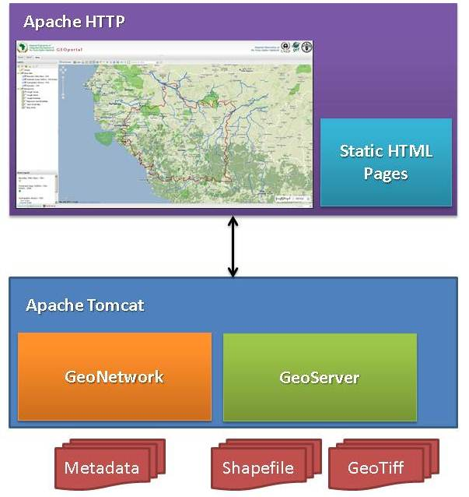

Figure 1 - Overall infrastructure for the FDH GeoPortal

In Figure 1 a high level drawing of the components that compose the FDH GeoPortal is presented, in the next section we are going to provide additional details about each of them. Before proceeding we believe it is however important two mention a few basic facts about the GeoPortal for those who might not want to dive into next detailed sections.

The GeoPortal is a distributed service oriented architecture where we can identify two main components:

1. The WebGIS interface, which provide a unique comprehensive interface to present mapping, searching and portal capabilities. It acts as a client to the other server side components.
2. The Server Side components, responsible for providing the capabilities to search for information and resources as well as the capabilities to overlay maps and information onto one another

Eventually it is also worth to point out that all the components employed for the development of the GeoPortal are Free and Open Source.

## Client-Side Architecture

The User Interface for the FDH GeoPortal is depicted in Figure 2. It provides a comprehensive user interface that puts together the main functionalities requested by the normal user, grouping under 3 tabs:

1. **Portal,** to expose static HTML pages to provide users with specific information and additional resources about the initiative itself
2. **Search**, which encapsulates the user interface of the server side search tool (we will discuss it in more details in next section) within a single tab of the overall UI itself, providing for the possibility to perform searches directly from the Portal as well as the View tab, but also for the option to directly load results of the searches into the Map Component of the view tab
3. **View**, which provides an advanced WebGIS interface with printing capabilities as well as with the possibility to directly query the Search tool from its layers or to trigger layers’ loading from both the Search Tab as well as the Portal tab.

The GeoPortal User Interface has been built leveraging on a highly customized version of the GeoExplorer [1]Open Source WebGIS.

## Server-Side Architecture

The server side architecture of the FDH GeoPortal is basically composed by two components:

* **Metadata Catalogue**, to perform refined searches on the geospatial resource made available as part of this initiative
* **Data Dissemination Server**, to provide management and dissemination of geospatial data, raster and vector under the form of maps as well as raw information.

The role of the Metadata Catalogue is played by the GeoNetwork[2] Open Source catalogue, while the Data Dissemination Server role is playted by the GeoServer[3] Open Source project. Although we do not intend here to do a feature comparison with other similar software or to provide an in depth analysis of their capabilities (plenty of information is available on their respective websites) It is worth to notice how both projects are widely used projects with an active vibrant community supporting them.

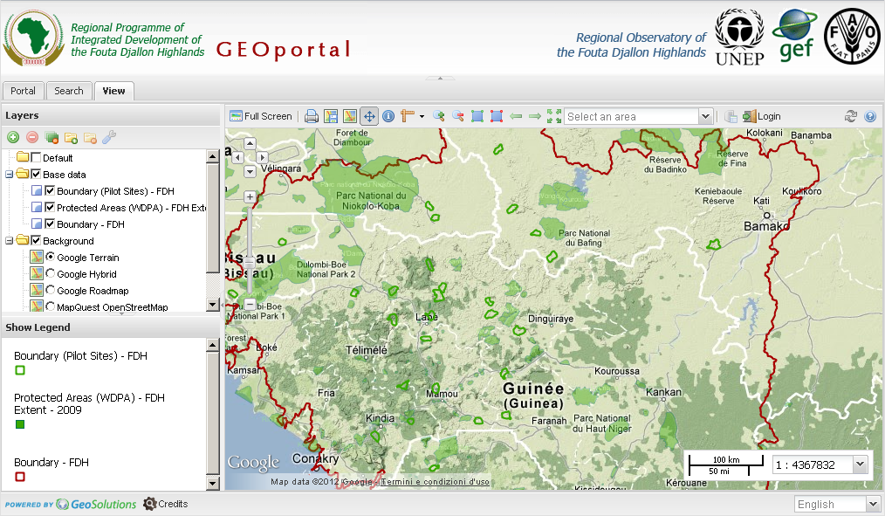

Figure 2 - FDH GeoPortal User Interface

## Multilingualism

Before explaining in more details the functionalities offered by the User Interface of the GeoPortal, we would like to mention that particular emphasis has been put on supporting multilingual (French and English) in order to ease the work for the non-English speaking people in the Fouta Djallon Highlands area.

All the tabs of the UI provides texts in both English and French and it is possible to switch at runtime between them through a drop down menu position at the bottom right corner of the UI itself (see Figure 3).

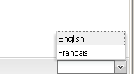

Figure 3 - Language Dropdown box

# Portal Page

The first tab of the FDH GeoPortal User Interface encapsulated the **Portal Page**, which provides a set of HTML pages specifically created by the FAO team working on the FDH GeoPortal initiative in order to provide additional information and resources to users (see Figure 4).

Such pages are provided in both English and French and include the following:

* Simplified means to perform searches
* Links to the WebGIS as well as the search interface
* Links to the official FDH portal
* Documentation about the WebGIS as well as the GeoNetwork catalogue that is the backend of the search interface
* News and links to external fresh sources of information that are of interest for the project.

Summarizing the Portal Page aims to provide an entry point to the FDH GeoPortal, bringing together useful information for the inexperienced users as well as link to the other relevant functional components of the GeoPortal itself.

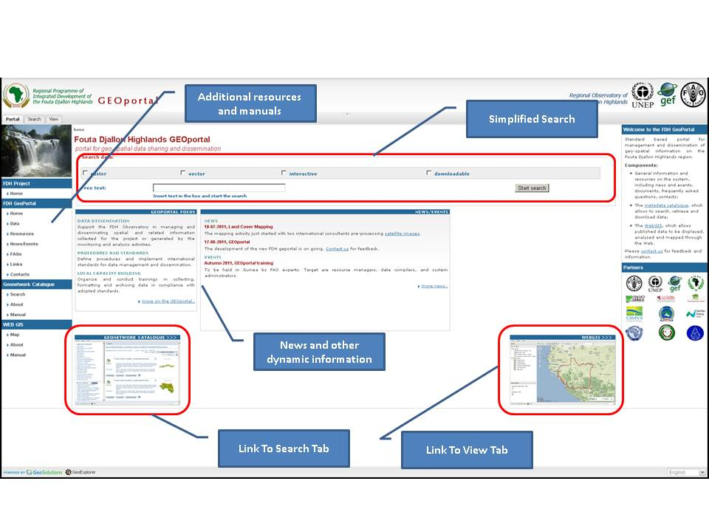

Figure 4 - Contents of the Portal Tab

# Search Page

The second tab of the FDH GeoPortal User Interface is the **Search Page**, which encapsulates a simplified version of the GeoNetwork Open Source metadata catalogue user interface.

Providing detailed information about the GeoNetwork catalogue is out of the scope of this document, actually the portal pages contain links to the user manual however it is worth to briefly explain here how to perform basic searches through the provided user interface.

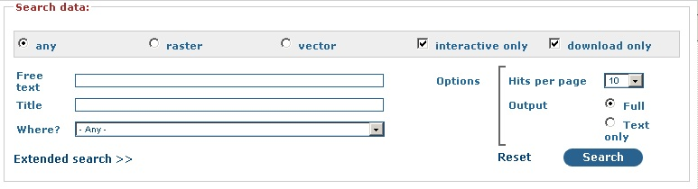

Figure 5 – Simple Search

**Simple search form allows performing free text search on the catalogue. The user can filter search result by type (raster, vector, any), content (interactive map, downloadable content) or area. Clicking on “Extended search” link allows having a more complete list of search options.**

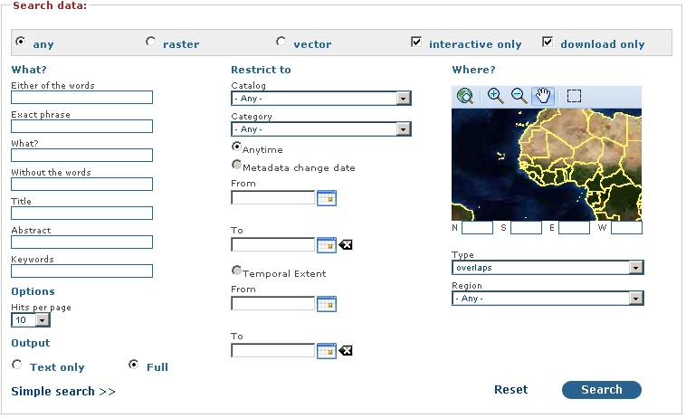

Figure 6 – Extended Search

The user can restrict search to a specific catalogue or category, search by temporal extent or metadata change date, selecting specific areas on the map.

# View Page

## Overview

In this chapter we are going to provide detailed information about the **View,** which encapsulates a highly customized version of the GeoExplorer Open Source mapping client. The view page is responsible for providing standard WebGIS for viewing and consuming the geospatial layers that have been made available for the project as well as layers coming from external Web Map Service[4] implementations as we will demonstrate in the next chapter.

In the next sections of this chapter we are going to briefly introduce the various panels (see Figure 7 for reference) that compose the View Page in order to allow the user to comprehend the functionalities they provide.

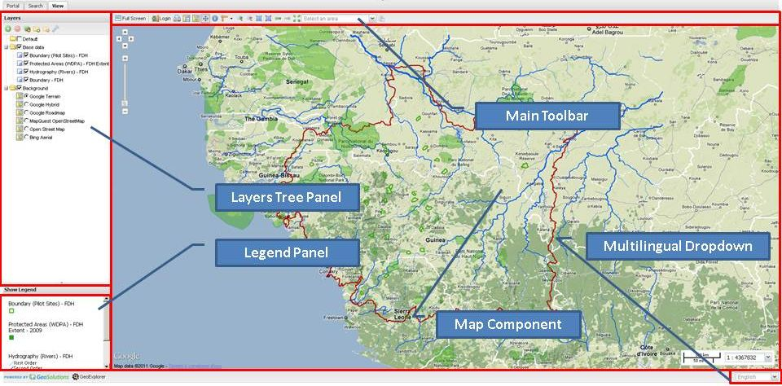

Figure 7 - View Page Components

## Layers Tree Panel

The Layers Tree Panel is devoted to manage the layers that the WebGIS show on the Map Component in terms of which layers to show, with which stacking order and with which properties. Referring to Figure 8, we are now going to introduce some additional information about how to interact with this panel.

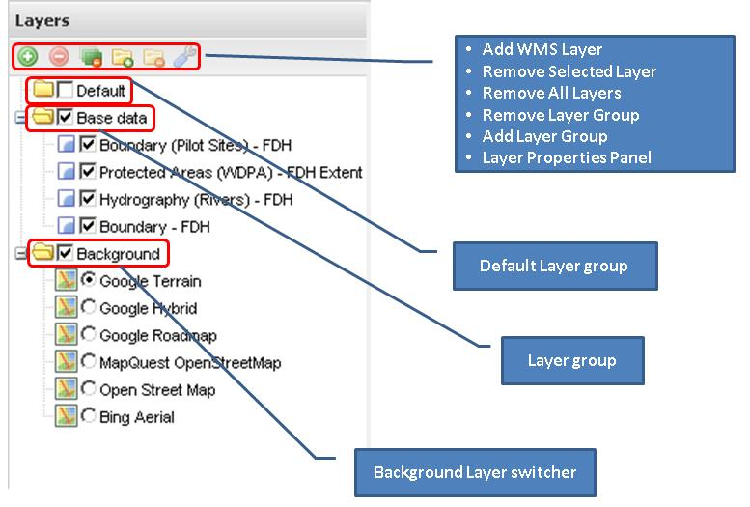

Figure 8 - Layers Tree Panel explained

The Tree itself is composed by a certain number of nodes, called **Layer Groups**, with leaves that represent layers that can be shown on the map. Layers can be dragged inside the same group or between different groups in order to control the stacking order on the map. Two layer groups are always present:

* **Default**, which is used to hold newly added layers which can then be dragged to other layer group as needed
* **Background**, which contains a certain number of standard high resolution and high speed layers served by famous vendors like Google of Bing. The leaves inside this layer group cannot be removed and only one of these layers at a time can be activated as it is used as the background for the map

New layer groups can be added between these two to group layers together. Each group as a checkbox which control the visibility of all the layers contained in it in an on-off fashion. Groups can be dragged around in order to vary the stacking order of the layers they contain with the exception of the **Default** and the **Background** groups which cannot be moved around.

The top part of the panel is occupied by the panel’s toolbar, whose buttons are described here below:

* http://demo1.geo-solutions.it/FDHWebGis-dev/externals/gxp/src/theme/img/silk/add.png Opens up the WMS Server Management panel (which we are going to describe in the following) which can be used to add new layers to Map Component from the FDH Data Dissemination Server (called FDH GeoServer) or from external WMS Servers
* http://demo1.geo-solutions.it/FDHWebGis-dev/externals/gxp/src/theme/img/silk/delete.png Can be used to remove the currently selected layers in the tree. **It is worth to point out that background layers cannot be removed**
* http://demo1.geo-solutions.it/FDHWebGis-dev/externals/gxp/src/theme/img/geosilk/layers_delete.png Can be used to remove all layers, except the background layers, from the tree
* http://demo1.geo-solutions.it/FDHWebGis-dev/externals/gxp/src/theme/img/silk/folder_add.png Can be used to add a new layer group to the tree
* http://demo1.geo-solutions.it/FDHWebGis-dev/externals/gxp/src/theme/img/silk/folder_delete.png Can be used to remove the selected layer group from the tree
* http://demo1.geo-solutions.it/FDHWebGis-dev/externals/gxp/src/theme/img/silk/wrench.png Can be used to open up the **Layer Property Window** view all the properties of the selected layers as well as to set some of them like the style used to visualize it or the format used for requesting (see Figure 9).

Before moving on with the next widget it is worth to provide some basic information about the **Layer Property Window.** Referring to Figure 9, the window is composed by a certain number of tabs as follows:

* **About**, which provide additional descriptive information about the selected layer
* **Display**, which can be used to control the opacity and the format of the selected layer
* **Cache**, which can be used to disable client side (browser based) caching of the selected layer
* **Styles**, which can be used to control which style we use to show the selected layer on the map as well as to inspect the relative legend

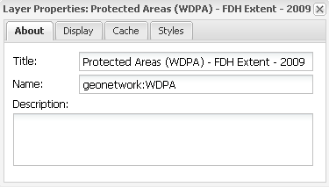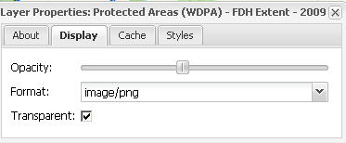

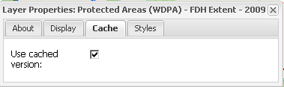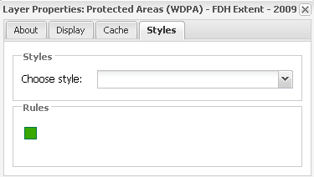

Figure 9 - Layer Property Window

## WMS Management Panel

By clicking on the **Add Layers** button from the Layers Tree Panel the **WMS Management Panel** is shown (see Figure 10). The panel provides a few additional controls as follows:

* The top drop down box provides a list of preconfigured servers from which layers can be obtained
* The central grid provide information about the layers served by the server selected in the drop down box
* We have an “Add a New Server” button in order to allow us to add an additional server (WMS or WMTS) as shown in Figure 11
* We have the button in the bottom right corner to either add to the current map the selected layer from the selected server or to close the panel itself
* We also have the capabilities to filter the layers’ grid via a text box at the bottom left corner. The “Clear Filter” button can be used to remove any filtering (see Figure 13)

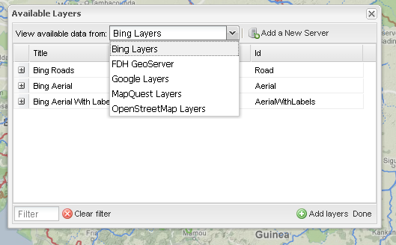

Figure 10 - WMS Management Panel

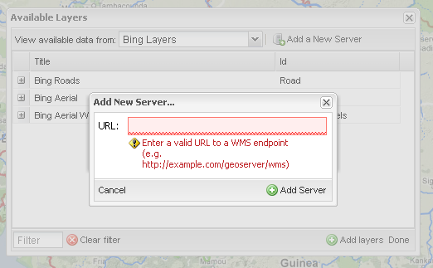

Figure 11 - Panel to add an external server

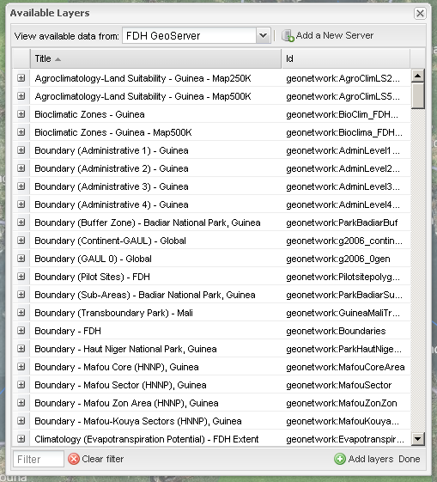

Figure 12 - Unfiltered list of layers

It is worth to remark on the fact that all the newly added layers are by default added to the **Default** layer group in the Layers Tree Panel. Users can then drag it to other groups as needed.

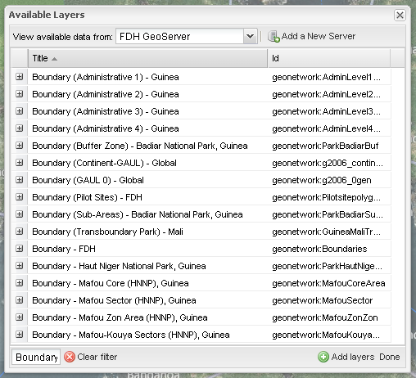

Figure 13 - Filtered list of layers over the Boundary keyword

## Legend Panel

The Legend panel is responsible for showing the legend of the layers that are visible on the map (see Figure 14)

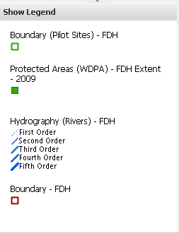

Figure 14 - Legend Panel with legends for the various published layers

## Map Component

The map component is represented in Figure 15 along with its embedded controls. The role of this component is obvious, therefore we just want to point out that the zoom and pan controls can be used to control the map position and that the scale control can be used to select the global scale of the map changing on the fly depending on the selected value in the drop down box.

## Map Context Management

With the term **Map Context** we denote in, our implementation, a file format that includes information about the server(s) providing layer(s) in the overall map, the bounding box and map projection shared by all the maps, sufficient operational metadata for the WebGIS to reproduce the map, and ancillary metadata used to annotate or describe the maps and their provenance for the benefit of human viewers. Generally speaking it contains the configuration that is used to build the View Tab in terms of layers served as well as components appearance and layout.

In this implementation the WebGIS is drive by a single Map Context that can be modified only by those having administrative privileges. All other users can add and remove layers, add and remove group, export and save on local disk the current Map Context and then reimport it later, but they cannot save the result of their work back to the server. This means that unless an administrator save his changes to the Map Context all the users will always see the same exact configuration of the WebGIS in terms of layers and controls every time the reload the initial page. As already mentioned they only allowed to persist locally and then reimport their changes.

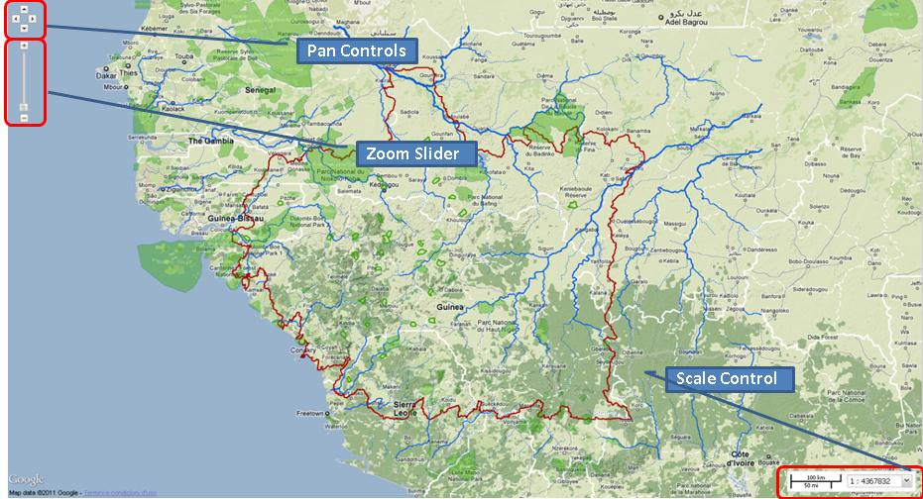

Figure 15 - The Map Component with its basic controls

### Importing/Exporting the Context

Employing the appropriate buttons on the Main Toolbar it is possible to persist on the local computer of the user the current Map Context in the form of an XML file. In a similar fashion the user can later on reload the same definition and modify accordingly the WebGIS layers layout (see Figure 16 ).

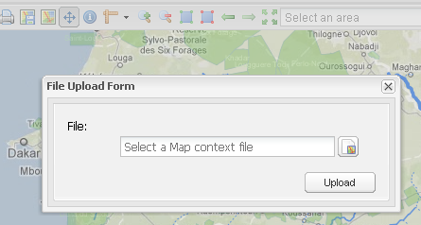

Figure 16 - Importing a local definition of a Map Context

### Area of Interest Switch

In Figure 17 the Area of Interest Switch dropdown is depicted. Such a control can be used to quickly and immediately center the map on different areas of interest without having to interact with the map itself. The AOIs (short for Area of Interest) are configured on the server though a flexible text files and therefore can be changed by an Administrator

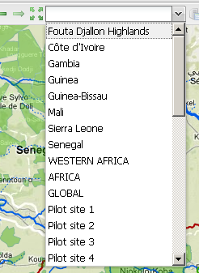

Figure 17 - Available Areas of Interest

### Save Current Context (Administrators Only)

As shown in Figure 18 through the login button, and providing that one possesses the right credentials, it is possible to enable the **Save Context** button which make the current Map Context Definition the default one, which mean that from that moment on all users will be presented with the ma as configured before saving (same layers, same layers’ order, same layers’ properties and so on).

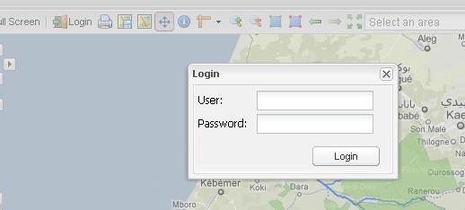

Figure 18 - Login panel for activating administrations controls

It is worth saying that once the login is successful the Login button is replaced by the logout button to allow Administrator to log out.

## Toolbar

In Figure 19 the **Main Toolbar** of the WebGIS is shown along with its buttons which we are now going to describe in detail.

C:\work\projects\fdh\geoexplorer\manual\new screenshoots\main toolbar.png

Figure 19 - Main Toolbar

* http://demo1.geo-solutions.it/FDHWebGis-dev/theme/app/img/silk/application_view_gallery.png **Full Screen**, maximize the map to full screen
* Descrizione: http://demo1.geo-solutions.it/FDHWebGis-dev/externals/gxp/src/theme/img/silk/printer.png **Print**, opens up the print dialog to print the current map
* Descrizione: http://demo1.geo-solutions.it/FDHWebGis-dev/theme/app/img/geosilk/map.png **Export Map Context**, allows us to export the current map context
* Descrizione: http://demo1.geo-solutions.it/FDHWebGis-dev/theme/app/img/geosilk/map_save.png **Import Map Context**, allows us to import an existing map context
* Descrizione: http://demo1.geo-solutions.it/FDHWebGis-dev/externals/gxp/src/theme/img/geosilk/pan.png **Pan**, allows the user to pan the map
* http://demo1.geo-solutions.it/FDHWebGis-dev/externals/gxp/src/theme/img/silk/information.png **Info Tool**, allows the user to retrieve information about the values of the layers composing the map in a certain point by clicking onto it
* http://demo1.geo-solutions.it/FDHWebGis-dev/externals/gxp/src/theme/img/geosilk/ruler.png **Measure**, allows the user to measure distances on the ma
* http://demo1.geo-solutions.it/FDHWebGis-dev/externals/gxp/src/theme/img/silk/magnifier_zoom_in.png **Zoom In**, allows the user to zoom in the map
* http://demo1.geo-solutions.it/FDHWebGis-dev/externals/gxp/src/theme/img/silk/magnifier_zoom_out.png **Zoom out**, allows the user to zoom out the map
* http://demo1.geo-solutions.it/FDHWebGis-dev/externals/gxp/src/theme/img/silk/shape_square_green.png **Zoom Box In**, allows the user to perform box zoom in on the map
* http://demo1.geo-solutions.it/FDHWebGis-dev/externals/gxp/src/theme/img/silk/shape_square_red.png **Zoom Box Out**, allows the user to perform box zoom out on the map
* Descrizione: http://demo1.geo-solutions.it/FDHWebGis-dev/externals/gxp/src/theme/img/silk/arrow_left.png **Previous Extent**, it allows to undo the previous zoom action
* Descrizione: http://demo1.geo-solutions.it/FDHWebGis-dev/externals/gxp/src/theme/img/silk/arrow_right.png **Next Extent**, it allows to redo the previous zoom action
* Descrizione: http://demo1.geo-solutions.it/FDHWebGis-dev/externals/gxp/src/theme/img/silk/arrow_out.png **Zoom to world**, zoom the map to the maximum available extent
* **AOI Dropdown**, contains a certain number of Areas of Interest that can be used to quickly center the map extent on certain areas
* Descrizione: http://demo1.geo-solutions.it/FDHWebGis-dev/externals/gxp/src/theme/img/geosilk/server_table.png **Save Current Map Context (admin only),** this buttons is only available when the Administrator has logged in and allows him to save the modifications he has eventually made to the current map context
* Descrizione: http://demo1.geo-solutions.it/FDHWebGis-dev/theme/app/img/silk/door_in.png **Login**, allows the Administrator to provide credentials to login
* C:\work\projects\fdh\geoexplorer\manual\new screenshoots\refresh.png **Refresh:** refresh the page to restart
* **C:\work\projects\fdh\geoexplorer\manual\new screenshoots\manual.png Manual:** a link to this document

## Printing Capabilities

As mentioned previously, the FDH GeoPortal has the capability to print the current map extent in customizable way. It is in fact possible to select:

* **Paper Size**, between A3, A4
* **Resolution** in DPIs, between 127, 190 and 354
* **Whether or not to include the legend**
* **Whether or not to put the legend on separate page**

It is also possible to customize the title of the map we will produce using the text box provided in the print panel. Notice that the map is produced in the PDF format. Figure 20 and Figure 21 show the printing panel as well as the result of the selection made on it are.

**Please notice that when printing a user should select either the OpenStreetMap or the MapQuest OpenStreetMap background as the other cannot be printed as per their licenses.**

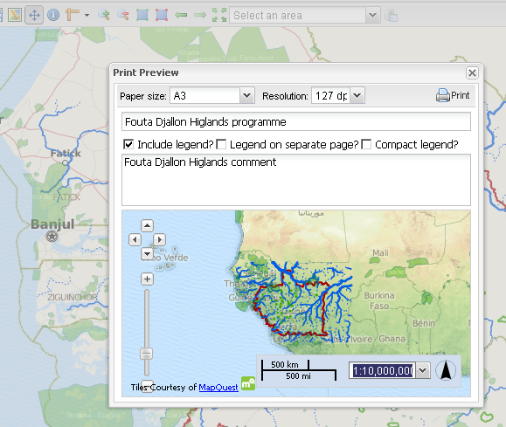

Figure 20 - Printing Panel

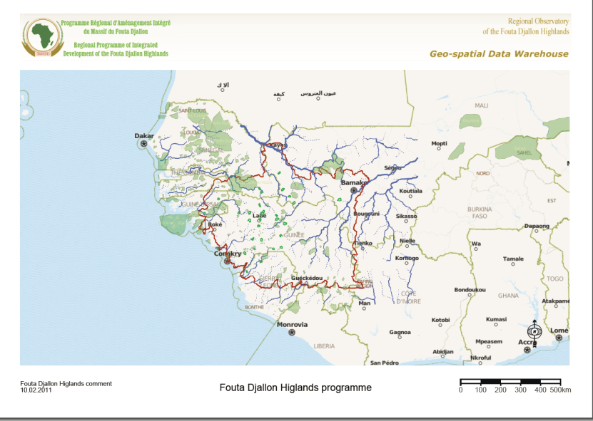

Figure 21 - Result of printing the previous map

# Common Use Cases

In this section we are going to cover the basic steps to perform common use cases in order to guide users through practical usage scenarios for the FDH GeoPortal by providing them with a series of screenshots showing the basic steps to be performed to reach their goal.

## Adding layers from the FDH WMS Server

This use case focuses on understanding to how to actually add a WMS layer from the GeoServer FDH server. Let’s assume we want to start with fresh clean GeoPortal and add the Guinea Fire 2001 layer.

### Step 1 – Open the WMS Management Panel

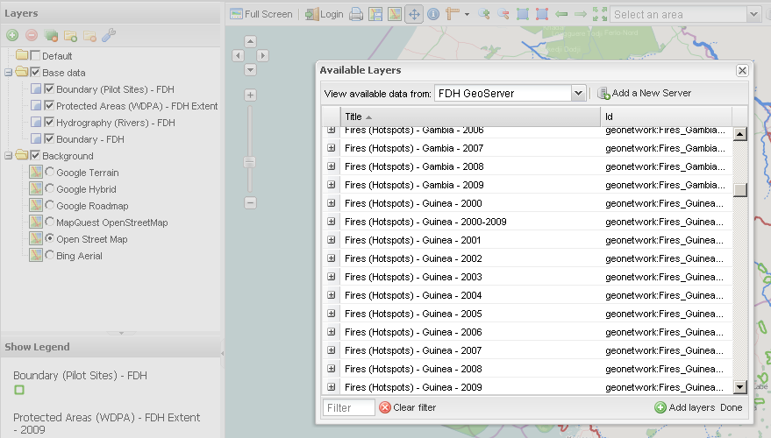

Figure 22 - Step 1 - Open the WMS Management Panel

### Step 2 – Select the FDH GeoServer from the Server’s List

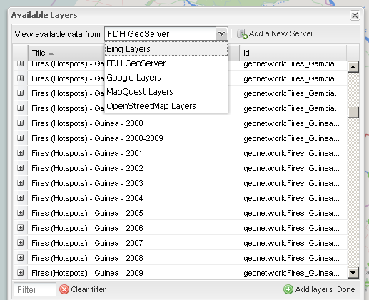

Figure 23 - Step 2 – Select the FDH GeoServer from the Server’s List

### Step 3 – Filter the Layers’ List

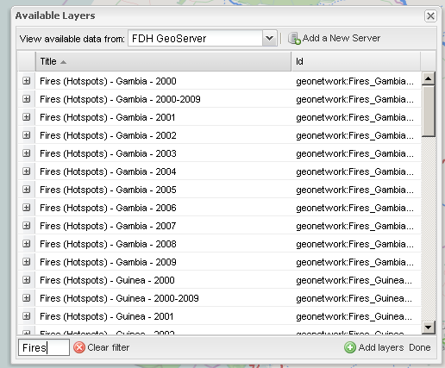

Figure 24 - Step 3 – Filter the Layers’ List

### Step 4 – Select the layer and Press Add Layers

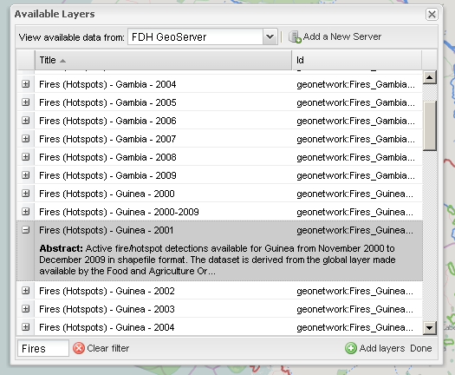

Figure 25 - Step 4 – Select the layer and Press Add Layers

### Step 5 (Optional) – Drag layer from Default Group to other Groups

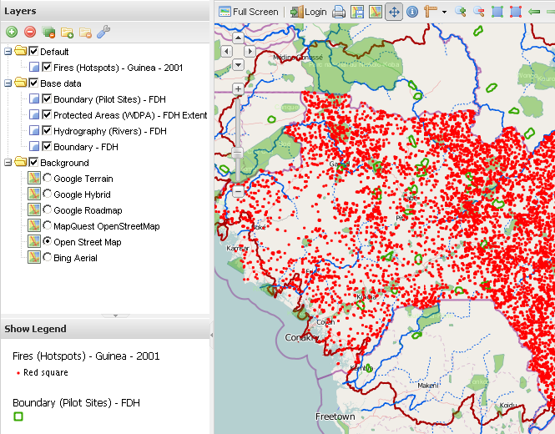

Figure 26 - Step 5 (Optional) – Drag layer from Default Group to other Groups

## Adding layers from an external WMS Server

### Step 1 – open the WMS management panel and click on “Add a New Server” button

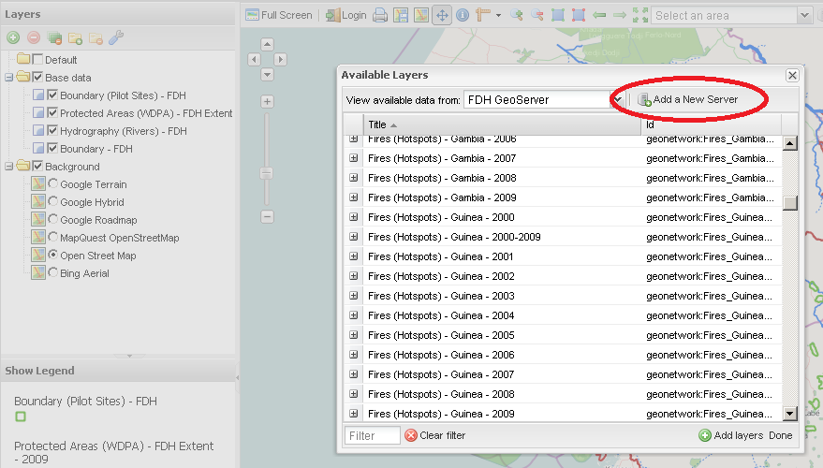

Figure 27 – Step 1 – WMS management panel” Add a New Server” button

### Step 2 – Digit a valid WMS service URL, click on “Add Server” and wait for the of the layer list.

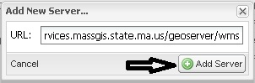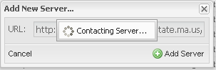

Figure 28 –Step 2 – Add WMS Server URL

### Step 3 – Select a layer from the list to add to the map.

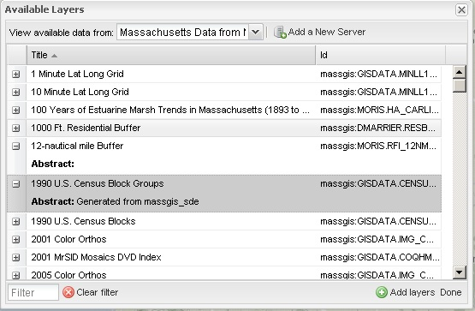

Figure 29 – Step 3 – select a layer from the list

## Load WMS layers from the Search View

### Step 1 – Click on the “Interactive Map” link in the search result entry

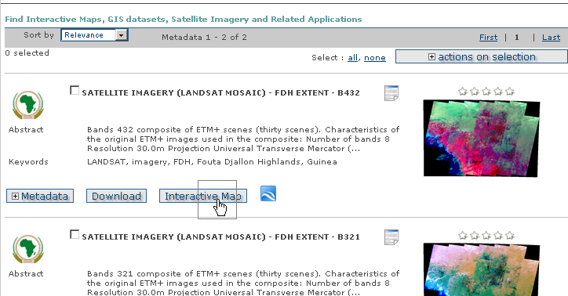

Figure 30 – Interactive Map link in search results

### Step 2 – The layer will be automatically updated to the map.

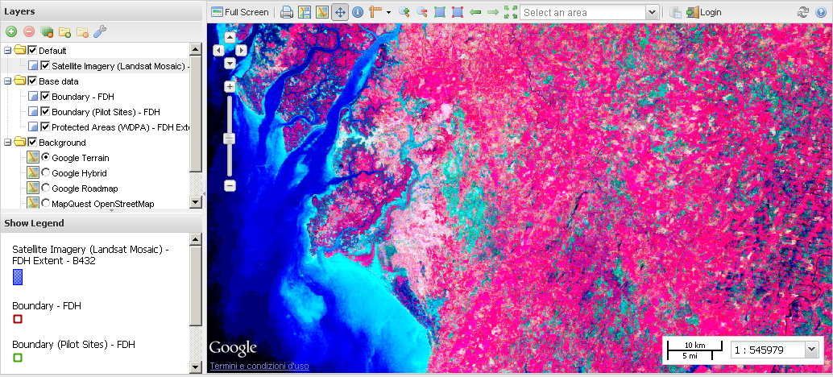

Figure 31 – The layer automatically added to the map

## Search Metadata for a Map Layer

### Step 1 – Right click on a layer to open the context menu and click on “View Metadata”

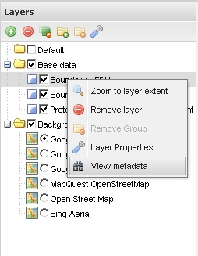

Figure 32 – Contextual Menu

### Step2 – The layer metadata will be automatically searched in the “Search” tab

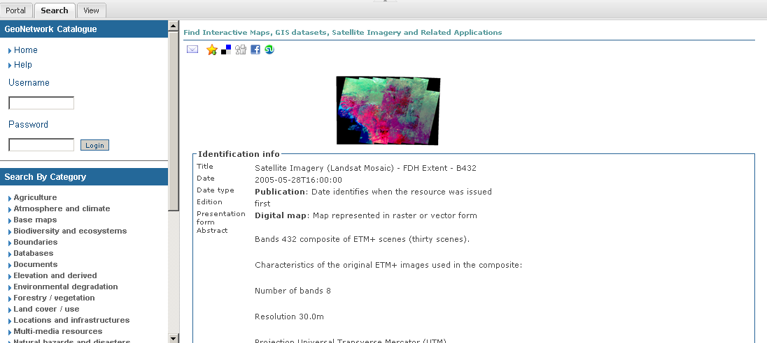

Figure 33 - The metadata page in the Search Tab

# Print Current Map

This use case focuses how to print the current map with the FDH GeoPortal.

### Step 1 – Open the Print Dialog

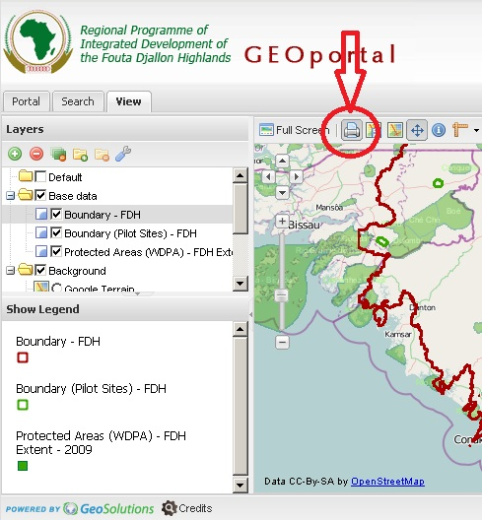

Figure 34 - Step 1 – Open the Print Dialog

### Step 2 – Select Paper Size and Resolution (DPIs)

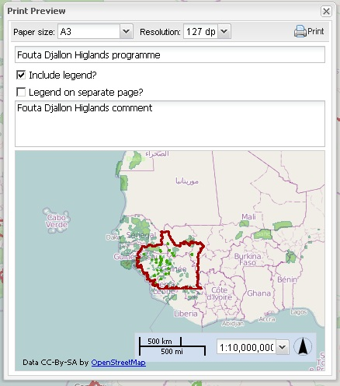

Figure 35 - Step 2 – Select Paper Size and Resolution (DPIs)

### Step 3 – Decide options for Legend Positioning



Figure 36 - Decide options for Legend Positioning

### Step 4 – Click on the Print button



Figure 37 - Step 4 – Click on the Print button

1. <http://suite.opengeo.org/geoexplorer/composer>
2. <http://geonetwork-opensource.org/>
3. <http://geoserver.org/display/GEOS/Welcome>
4. <http://en.wikipedia.org/wiki/Web_Map_Service>